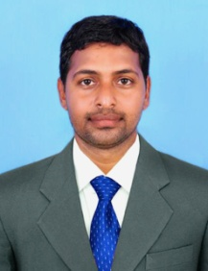

**STAFF PROFILE**

|  |  |  |  |
| --- | --- | --- | --- |
| Name | : | **Dr.N.SATHISH BABU** | |
| Designation | : | **Assistant Professor** | |
| Qualification | : | **B.A.,B.P.Ed.,M.P.Ed.,Ph.D** | |
| Experience | : | **08 Months** | |
| **Sports Achievement** | | | |
| Represented State Level Volleyball Tournament 2005-2006 | | | |
| Represented National Level Volleyball Tournament 2007-2008 | | | |
| **Publication** | | | |
| **Particulars** | **International Level** | | **National Level** |
| Journals | 01 | | 01 |
| Conference | 02 | | 01 |